1. Note the Source and Destination columns in the Packet List containing IP addresses. You should see one particular IP address repeated in nearly every unicast packet as the Source or Destination. What is this IP address and what device does it represent? [Note: Looking for a general description, not specific device name or operating system]. Include a screenshot of the Wireshark window at this point with your response.

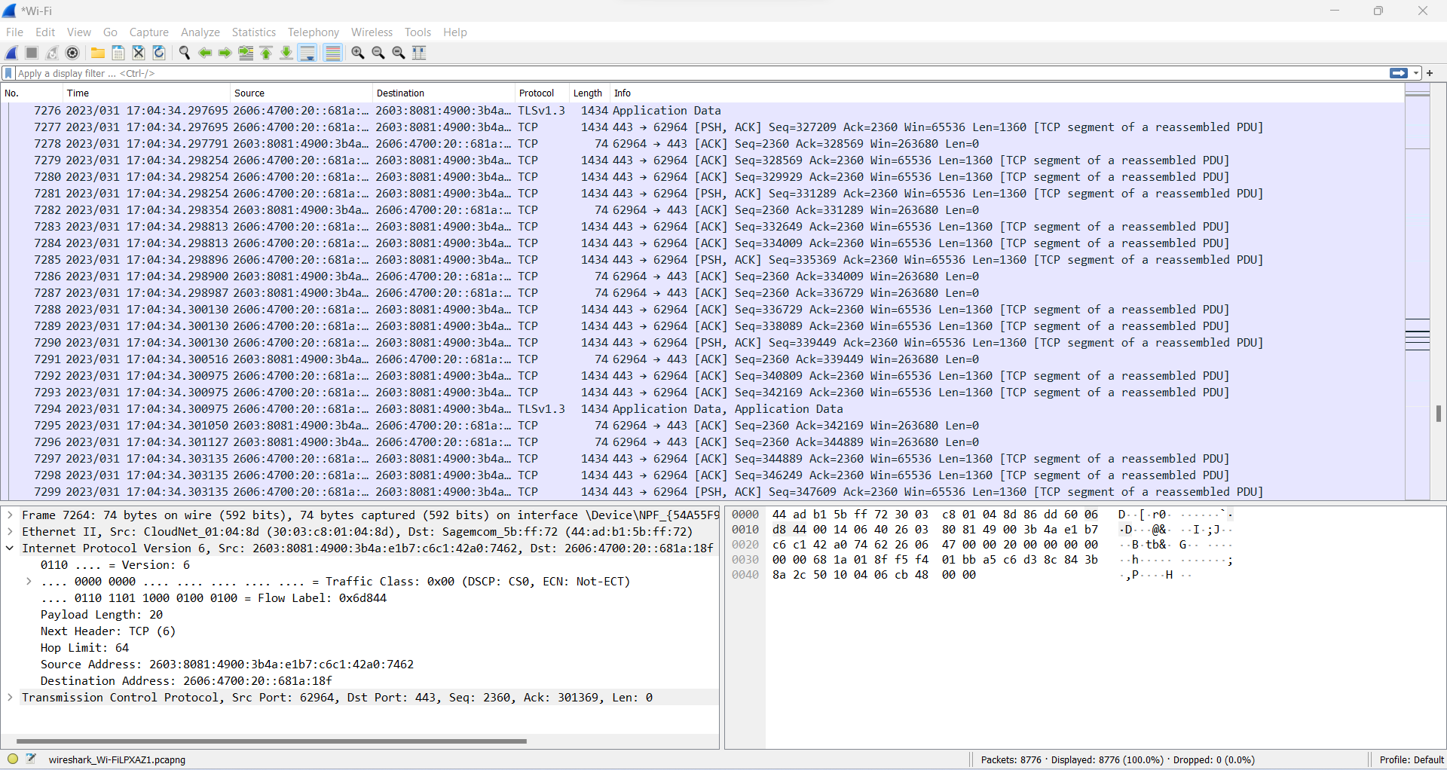

The IP address that is repeated in nearly every unicast packet as the source or destination is 2603:8081:4900:3b4a:e1b7:c6c1:42a0:7462. The device it represents is my computer’s temporary IP address.

1. Examine the Protocol column in the Packet List pane. Just estimating by scrolling through the packets, what protocol seems to be listed the most (Wireshark provides several ways to capture exact statistics like this, but such precision is not necessary for this introductory lab). Include a screenshot of the Wireshark window at this point with your response.

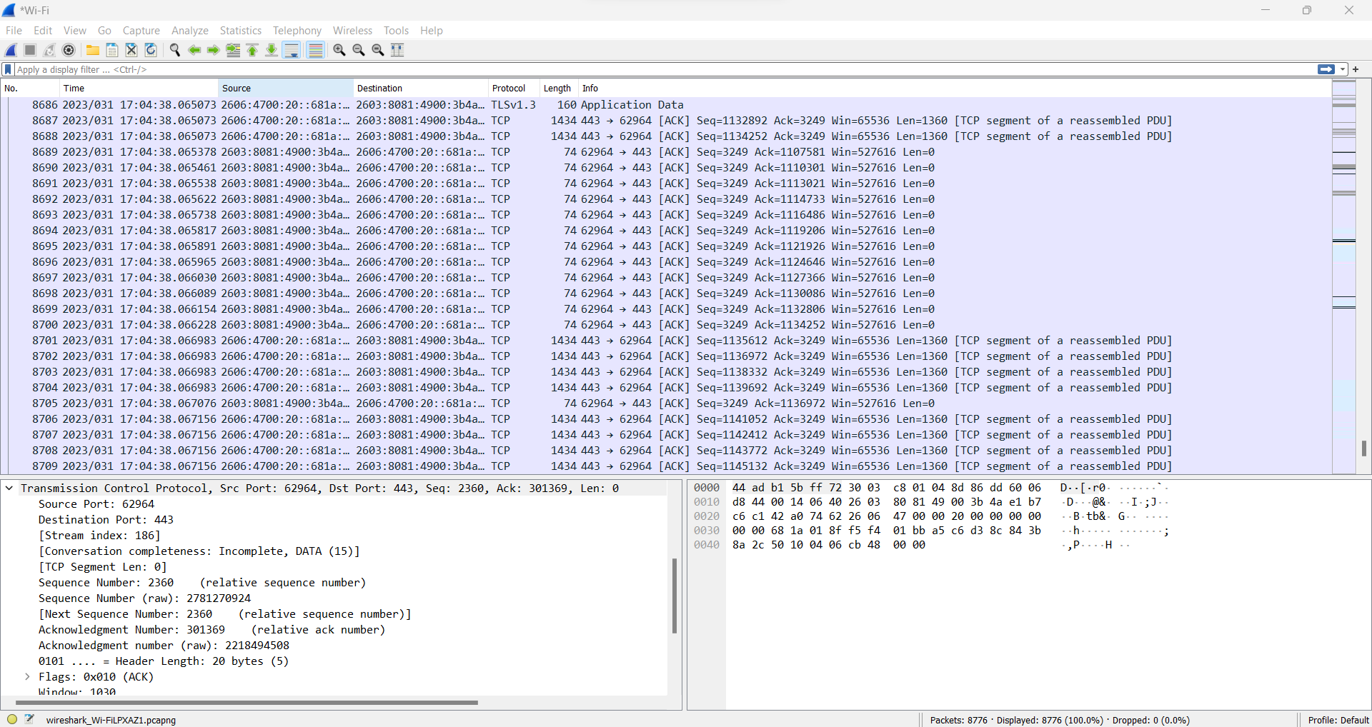

The protocol that seems to be listed the most is the TCP or the Transmission Control Protocol

1. Scroll down toward the middle of the packet capture and highlight one of the packets in the Packet List pane. Examine the information displayed in the Packet Details pane. *Without expanding any of the rows*, look at the information provided and identify which layers of the Internet/OSI model rows 2, 3 and 4 correspond to. Include a screenshot of the Wireshark window at this point with your response.

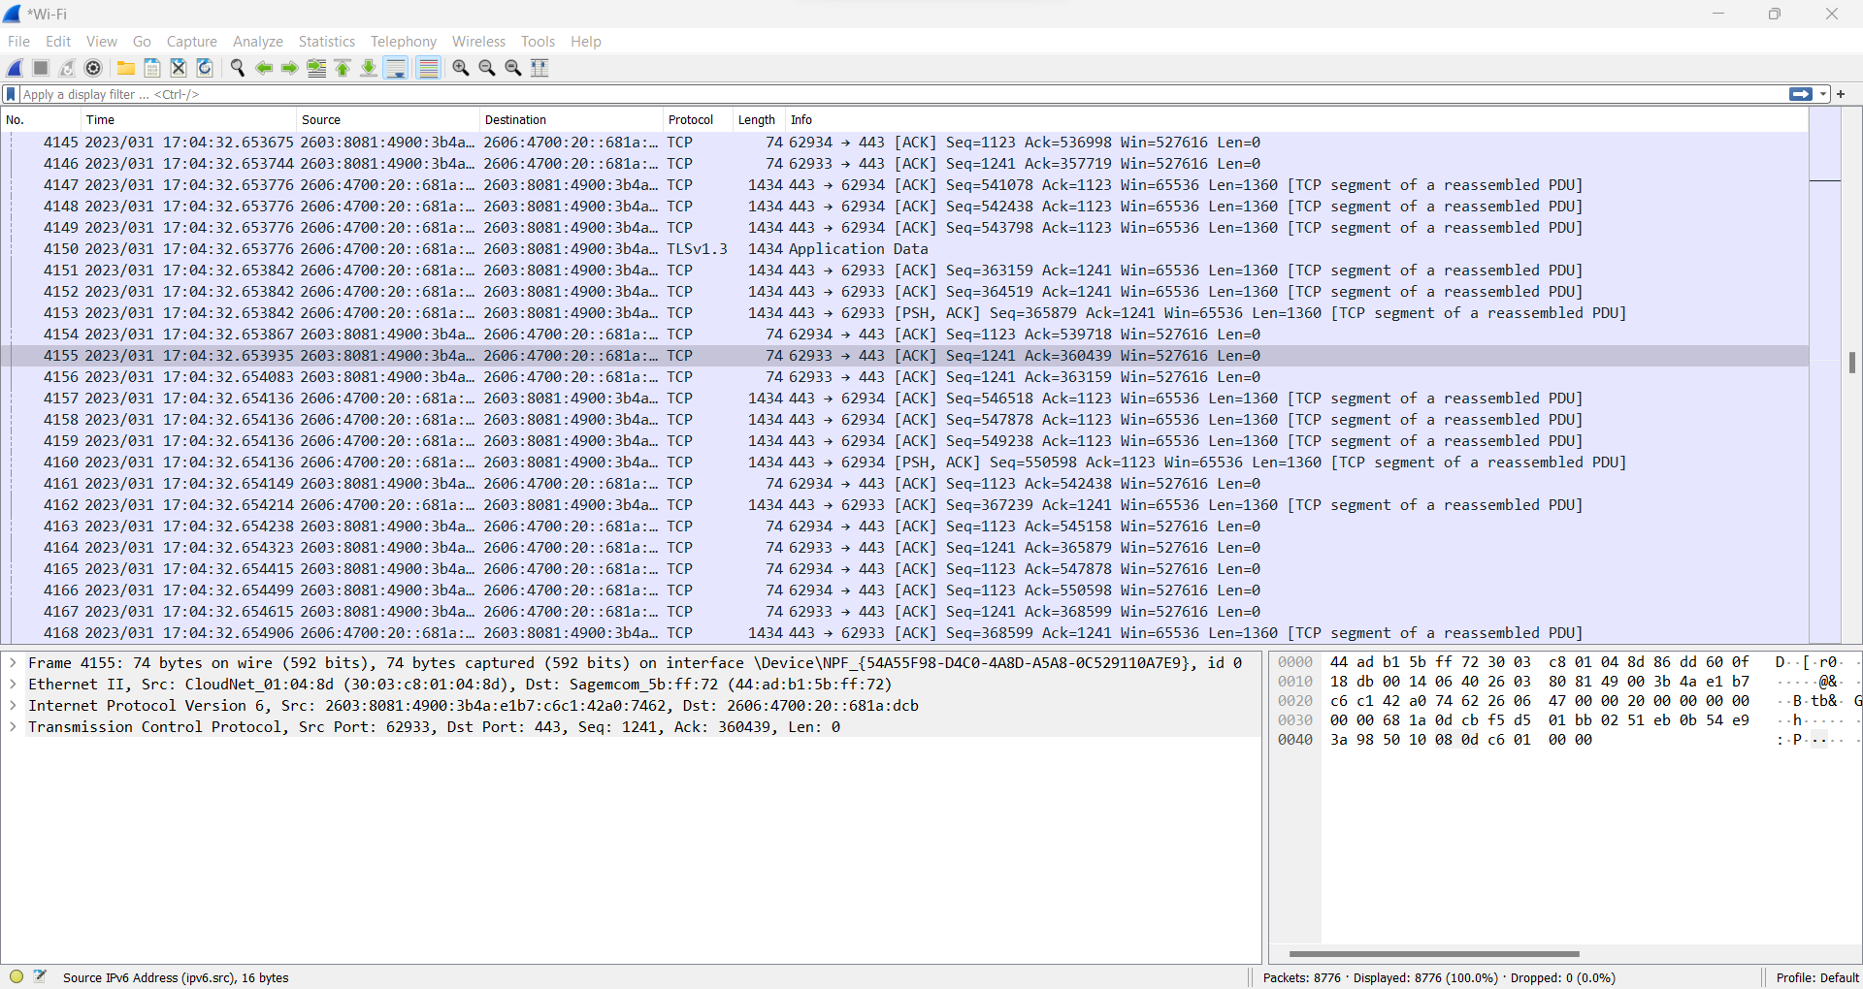

Ethernet II would correspond to the Data Link Layer, Internet Protocol Version 6 would correspond to Network Layer, Transmission Control Protocol would correspond to Transport Layer.